10. Information Architecture
Wireframes and Rationale
The IA above sets out the zones and modules. The subsections below turn it into screens: a screen inventory, low-fidelity wireframes and the usability and accessibility reasoning behind them. The wireframes fix structure, content and behaviour, not visual style, so reviewers judge what each screen does. Final styling is not required in M2.

Clickable prototype: It covers all eleven screens, a phone-width view and numbered notes that trace each design choice to a REQ, ASR or decision ID. The screenshots below are the controlled copy and are also stored in the repository under docs/design/wireframes/.
10.1 Screen inventory
Table 10-1. IA zones mapped to wireframed screens
IA zone (above) | Screens | Landing page | Requirements
Public / Auth zone | Register · Check your email · Sign in | Sign in | REQ-023, REQ-029, REQ-030, REQ-033 (D13, CR-004)
Requester portal (STK-001) | Submit request · My requests · Request detail | My requests | REQ-001 to REQ-006, REQ-027, REQ-031, REQ-035
Staff & triage portal (STK-002, STK-003) | Worklist · Request workspace | Worklist | REQ-007 to REQ-017, REQ-024
Management portal (STK-004, STK-005) | Oversight dashboard · Audit trail · All requests (read-only list) | Oversight | REQ-018 to REQ-022
Admin zone (STK-006) | Staff accounts and categories | n/a | Not wireframed in M2 (10.6)

Navigation is built from the signed-in user's user_type. A user never sees a menu item they are not allowed to use, which removes "access denied" dead ends and applies least privilege (REQ-029, ASR-002).
10.2 Wireframes
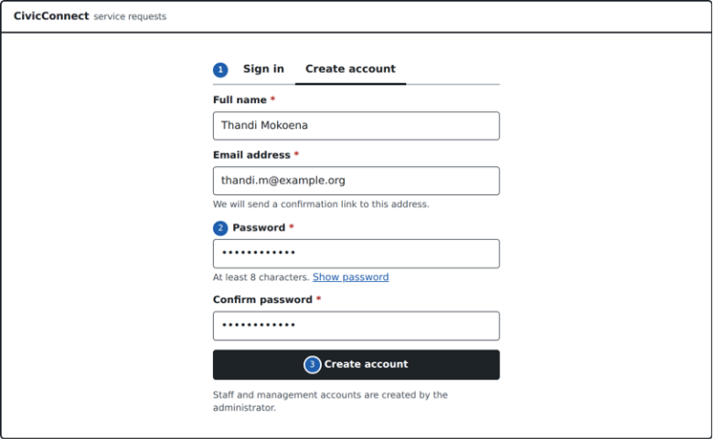
Figure 10-1. Create account: name, email and password; the account is confirmed by email before first sign-in (REQ-023, REQ-030, D13).
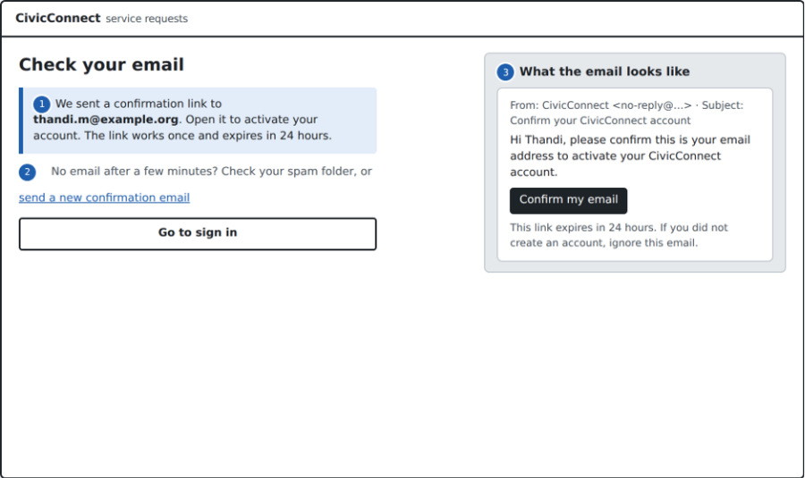
Figure 10-2. Check your email: generic confirmation page, resend option and the confirmation email itself (D13).
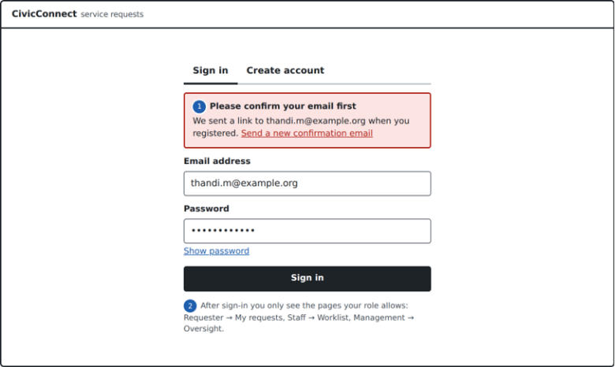
Figure 10-3. Sign in with email and password, showing the message for an account whose email is not yet confirmed (REQ-029, D13).
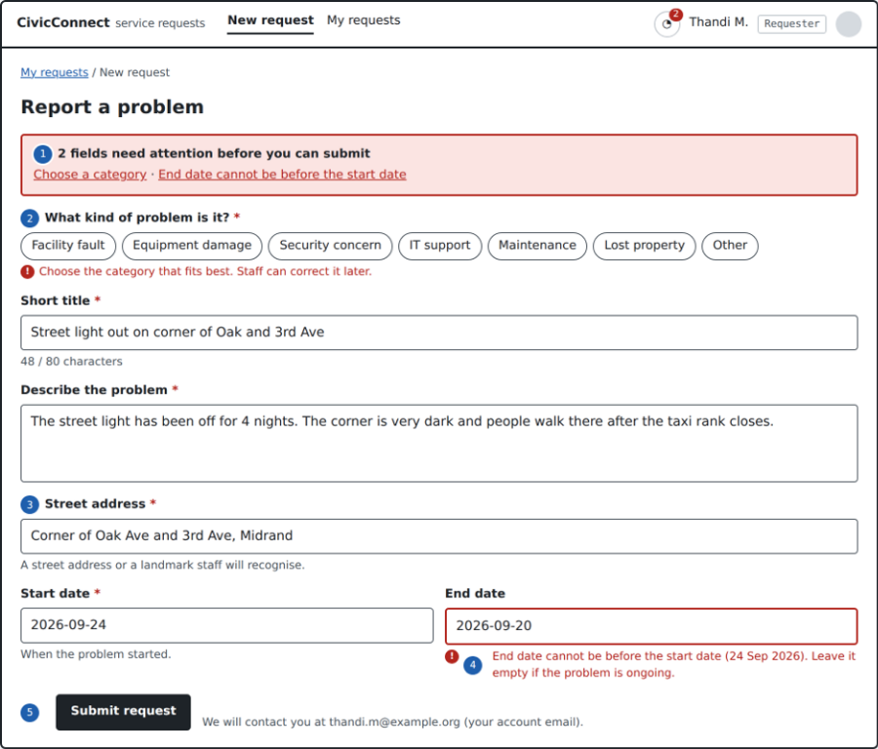
Figure 10-4. Requester: submit request in its validation-error state (REQ-001 to REQ-003; CR-001 street address, CR-002 no contact number).
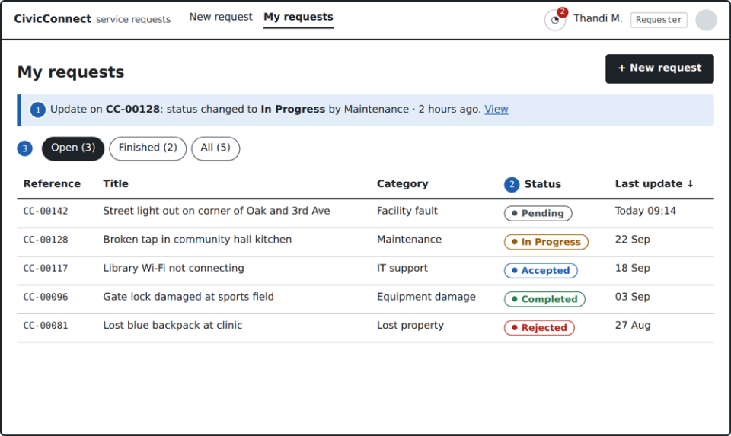Figure 10-5. Requester: my requests, with the latest feedback above the list (REQ-004 to REQ-006).
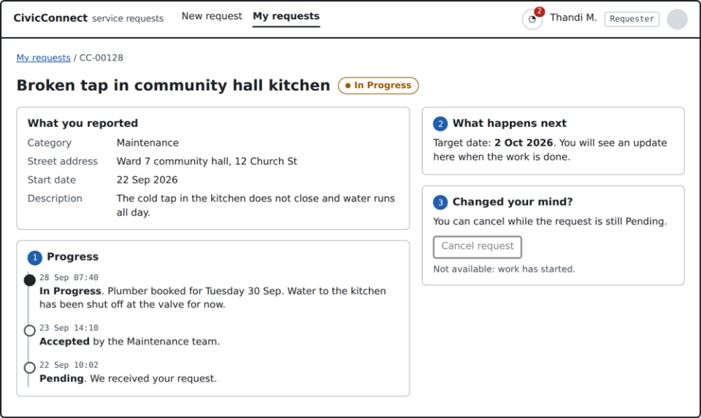
Figure 10-6. Requester: request detail and plain-language progress timeline read from the action table (REQ-004, REQ-006, S-IN-010).
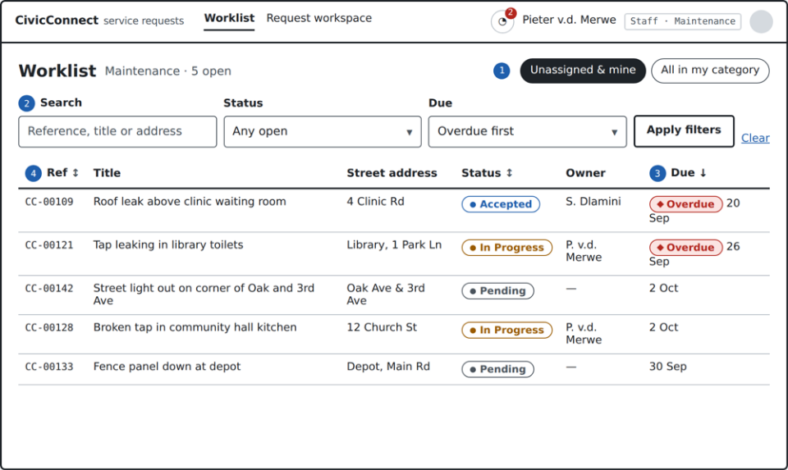Figure 10-7. Staff: worklist scoped to the staff member's category, with search, filter and sort (REQ-007, REQ-008, REQ-022).
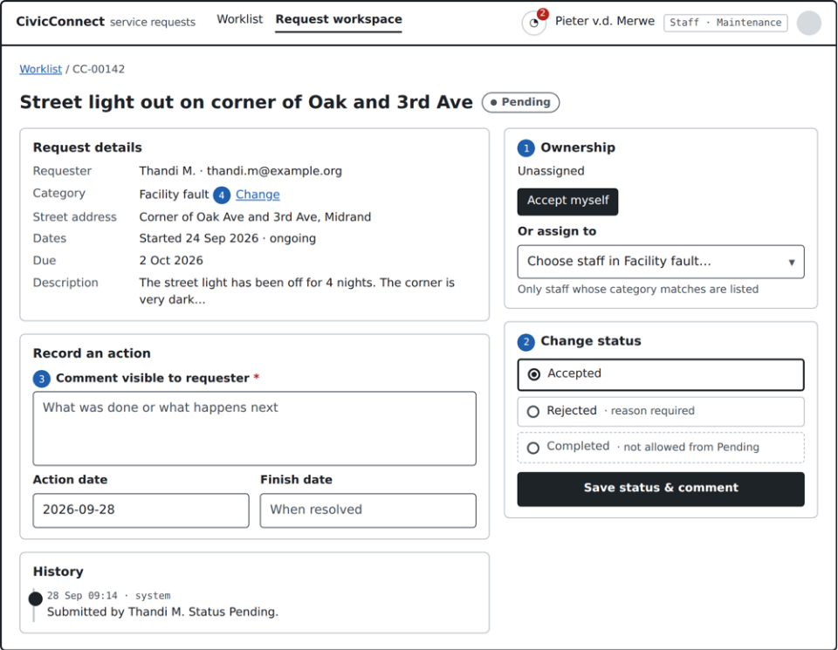Figure 10-8. Staff: request workspace for ownership, valid status transitions and actions (REQ-009 to REQ-017, REQ-024).
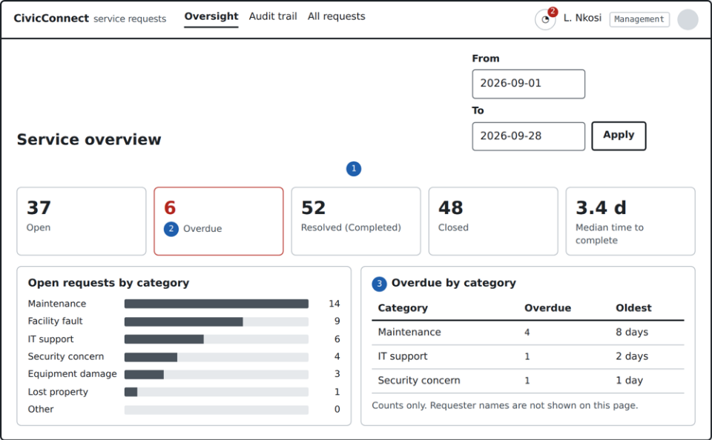
Figure 10-9. Management: oversight dashboard with open, overdue, resolved and closed counts (REQ-018 to REQ-020, REQ-022).
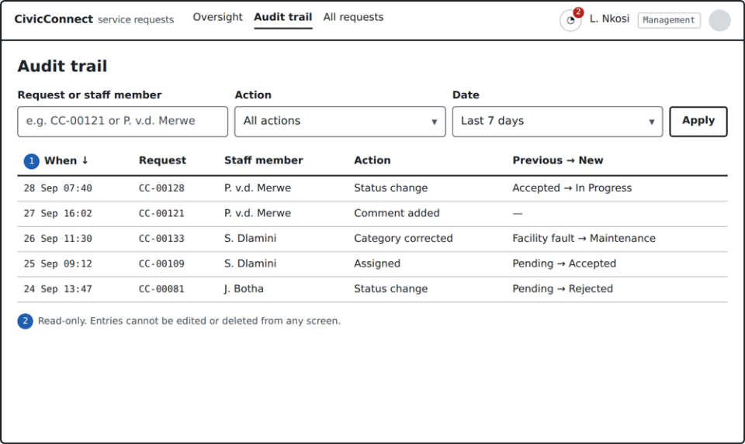Figure 10-10. Management: read-only audit trail built from action rows (REQ-021, ASR-009).

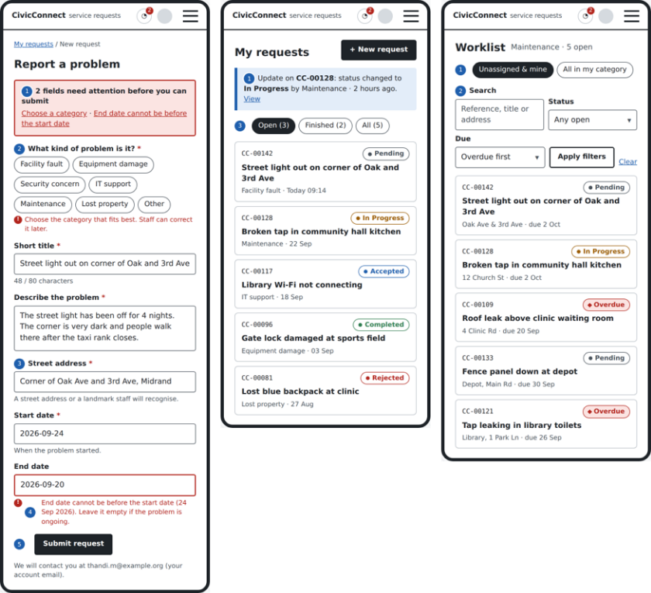
Figure 10-11. Phone width (390 px): tables collapse to stacked cards and navigation to a menu button (REQ-032, ASR-010).

10.3 Usability rationale
Each significant layout choice is tied to an established usability heuristic (Nielsen, 2024) and to the stakeholder need it serves.
Table 10-2. Usability heuristics applied
Heuristic | Design response | Screen | Serves
Visibility of system status | Status pill on every request; latest-update banner; plain-language timeline; target date shown; confirmation page states the link expiry | My requests, Request detail, Check your email | REQ-004, REQ-006, STK-001 "trust the request is not lost"
Match with the real world | Categories use the brief's own words; "Report a problem" instead of "Create service request"; one street-address field in local terms | Submit request | REQ-003, REQ-027, CR-001
Error prevention | Only valid transitions offered; submit disabled after the first click; staff list filtered to the request's category; end date checked against start date | Submit, Request workspace | REQ-011, REQ-013, REQ-031
Recognition rather than recall | All seven categories visible as chips; filter values as dropdowns; breadcrumbs | Submit, Worklist | REQ-003, REQ-008
Help users recover from errors | Error summary linking to each field; each message says how to fix it; "Resend confirmation email" on the check-email page and on the sign-in error | Submit, Check your email | REQ-002, D13
Consistency and standards | Same D10 status labels and pill style on every screen | All | REQ-004, REQ-019, REQ-022
Aesthetic and minimalist design | Requester form limited to the fields in REQ-001 after CR-001/CR-002; registration asks for name, email and password only | Submit, Register | PED §2.4 simplicity vs reporting depth
Flexibility and efficiency | Default staff view is "unassigned and mine"; overdue sorts to the top; the whole row is clickable; the confirmation link works on any device | Worklist, Check your email | REQ-007, REQ-008, STK-002

10.4 Accessibility rationale
The target is WCAG 2.2 Level AA (W3C, 2023), which gives the Section 5.9 quality boundary a testable standard. The criteria below shaped the wireframes; the right-hand column is the M3 verification.
Table 10-3. WCAG 2.2 AA criteria applied to the design
Success criterion | How the design meets it | Verification (M3)
1.4.1 Use of colour | Status pills combine colour, dot and word; overdue uses a border and label as well as red; errors use an icon and text | Greyscale screenshot review
1.4.3 Contrast (minimum) | Body text and controls at least 4.5:1 against the background; checked again when the final palette is set | Automated check (axe DevTools or Lighthouse)
1.4.10 Reflow | Single column at 320 CSS px; tables become cards; no horizontal page scroll | Browser at 320 px and 400% zoom
2.1.1 Keyboard, 2.4.7 Focus visible | All actions are buttons or links with a visible focus outline; clickable rows are also focusable links | Keyboard-only walkthrough of each core task
2.5.8 Target size (minimum) | Buttons and chips at least 24 × 24 CSS px (most are 38 px high) | Measure in browser dev tools
3.3.1 Error identification, 3.3.3 Error suggestion | Field message names the problem and the fix; summary at the top | Submit empty and invalid forms
3.3.2 Labels or instructions | Every field has a visible label, required marker and format hint | Automated check for unlabelled inputs
3.3.8 Accessible authentication (minimum) | Password fields allow paste and password managers (autocomplete attributes) and have a show-password toggle, so no memorised or retyped password is required; email confirmation is a single link | Register and sign in using a password manager and a screen reader
4.1.2 Name, role, value | Native HTML controls; error summary uses role="alert"; confirmations use role="status" | Screen reader spot check (NVDA)

10.5 Proposed measurable UI acceptance
REQ-027 ("intuitive to use") and REQ-035 (submit within 30 seconds) are not yet testable as written. The wireframes make them measurable, so CR-007 proposes:
- REQ-027: at least 4 of 5 first-time requesters complete "report a problem" and "check its status" without help in a moderated walkthrough of the M3 build.
- REQ-035: the median time from opening the form to confirmed submission is 60 seconds or less for a typed description of about 20 words. Thirty seconds is not realistic once a meaningful description is typed; the walkthrough will provide evidence either way. Registration time is measured separately because it depends on email delivery.
10.6 Deliberately deferred UI decisions
- Visual style, colour palette and typography: M3, once the component approach in the React build is settled.
- Administrator screens (staff accounts, categories): M3 design, after the administrator role question in Section 8.1 is resolved.
- Photo upload on the submit form: deferred scope S-DEF-004.
- Evidence still needed: one walkthrough with a person outside the team playing a requester, to check the category chips, error messages and the confirmation email before these screens are built.

